CS3350 Assignment 3 Due: Sunday, Oct.13, 11:59 p.m.

In this program, you will implement a postfix expression evaluator. See the slides “stacks.ppt” P. 19-P.23 for the algorithm you need to implement. You must use stacks (I provide LinkedStack.h/LinkedStack.cpp/StackInterface.h/Node.h/Node.cpp files for you to use)

Your Tasks:

Provide an assignment3.cpp driver file that contains the implementation of the function (evaluator) and a main method that calls and runs the function. The driver program should:

- Loops, asking the user to provide either a number (can be more than 1 digit!) or an operator (+ - / *)
- Stops the loop when -1 is entered (do not add -1 to the expression!)
- Evaluates the given postfix expression.
- Displays the final result of evaluating the postfix expression (on a line by itself - this should be the last line displayed by your program!)

Sample output:
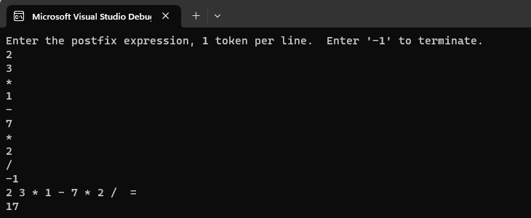

What to submit

- A single assignment3.cpp file

Grading Rubric

_______ (4) proper documentation/comments where appropriate.
______ (8) implementation of Evaluator.
_______ (8) implementation of the main method that calls and runs the function.

